**Installing git ,maven and Jenkins on EC2 Instance**

For installing GIT and Jenkins we need to login on ec2 instance using ssh connection after login

In in the ec2 machine login as

**# sudo root user**

For updating system type

**# yum update command**

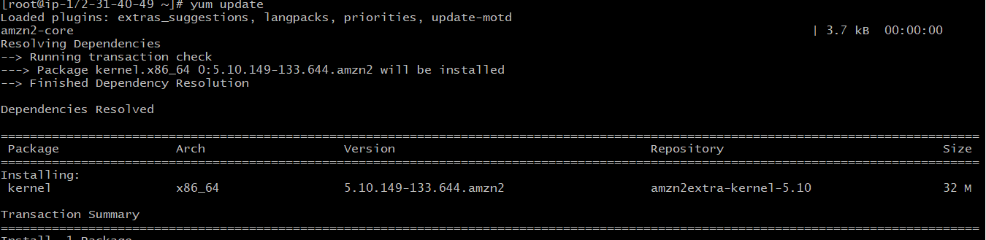

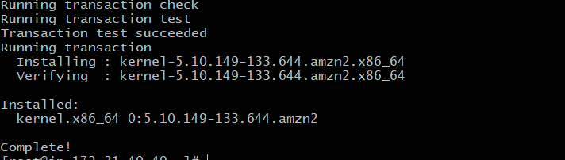

Then after updating system for installing get

**# yum install git**

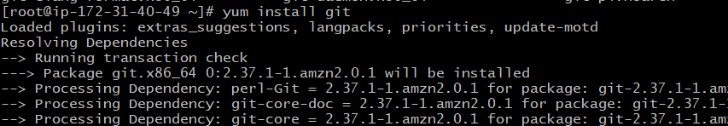

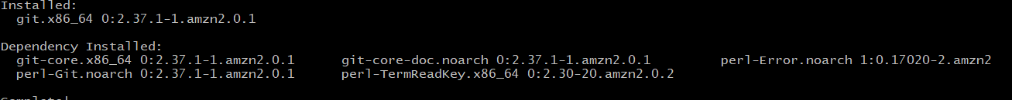

After installation of GIT ,maven we need to install Maven for integration of Maven command with gate type the following command

**# yum install Maven**

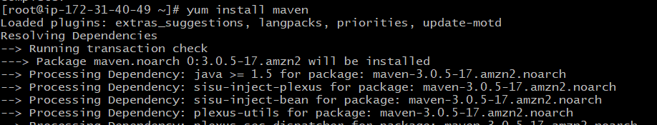

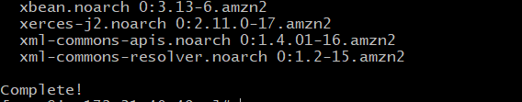

Then for installing Jenkins we need to install first Java on our machine. Use the following commands

**# sudo amazon-linux-extras install java-openjdk11 -y**

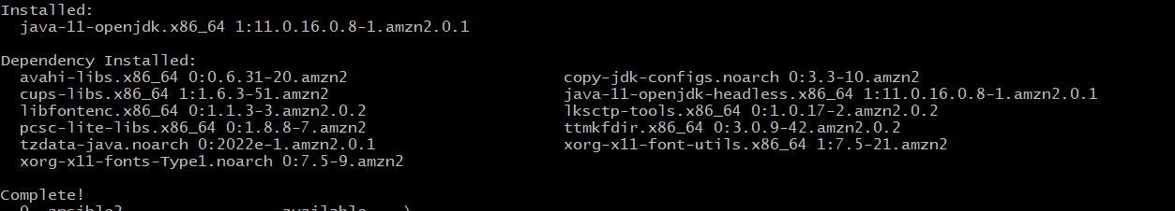

**# wget -O /etc/yum.repos.d/jenkins.repo \ https://pkg.jenkins.io/redhat-stable/jenkins.repo**

**# rpm --import https://pkg.jenkins.io/redhat-stable/jenkins.io.key**

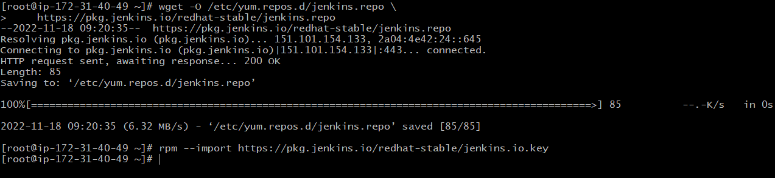

**# yum install Jenkins**

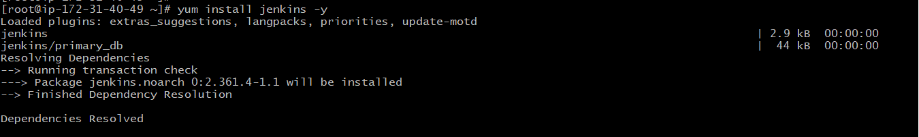

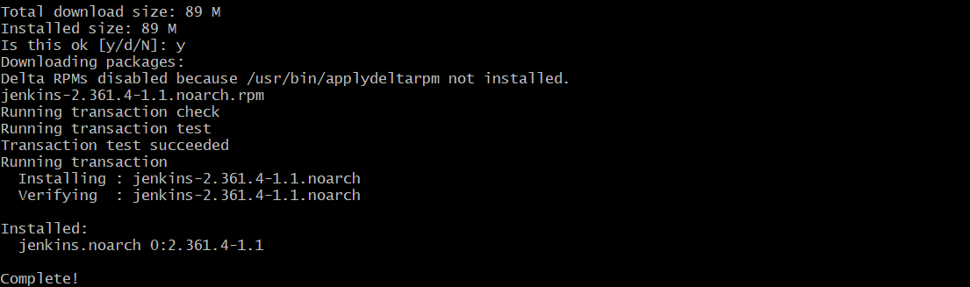

Then use the following commands to enable Jenkins from browser

**# systemctl enable jenkins**

**# systemctl start Jenkins**

After starting Jenkins server go to EC2 dashboard, copy public ip where Jenkins installed, paste it on browser the link given below

<http://52.66.197.185:8080/>

Unlocking Jenkins copy the path **initialAdminPassword** that is mention on jenkins browser and paste it to your git Bash terminal for getting password copy the password and paste it and press **continue** button. 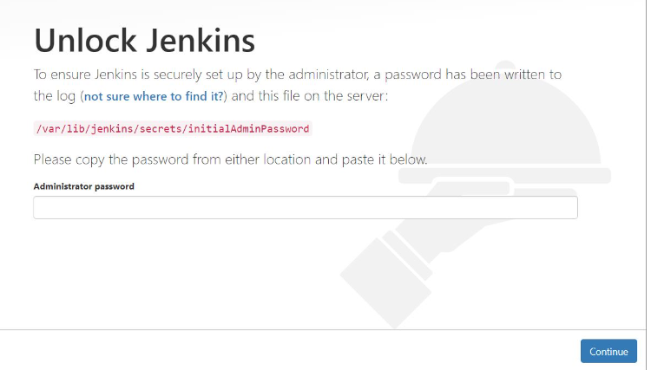

Jenkins installation directs you to the Customize Jenkins page. Click **Install Suggested Plugins**

After installation is complete you will redirect to **Create First Admin User** page, provide the details of username, password ,confirmed password ,full name and email address and click on save and continue.

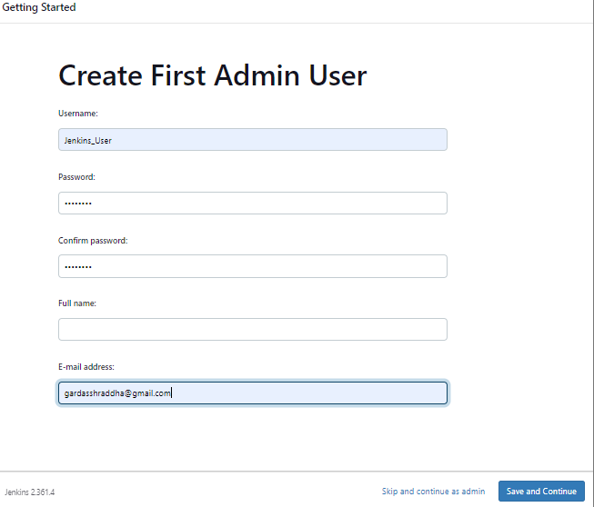

Finally Jenkins are ready to use click on **start using Jenkins.**

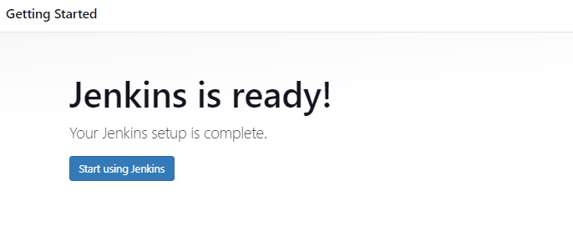

Configuring GIT and Maven on Jenkins go to login to your Jenkins server from dashboard go to manage Jenkins global tool configuration option

For getting path of the java and maven use **# mvn --version** command

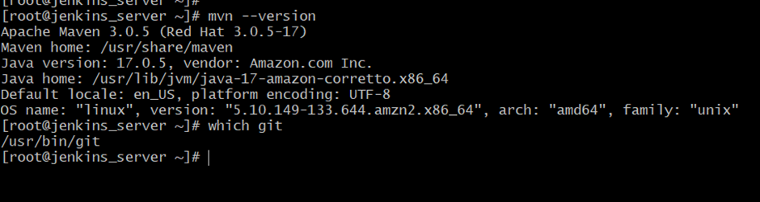

1. JDK installation click on add JDK name of JDK and path of **Java_Home**

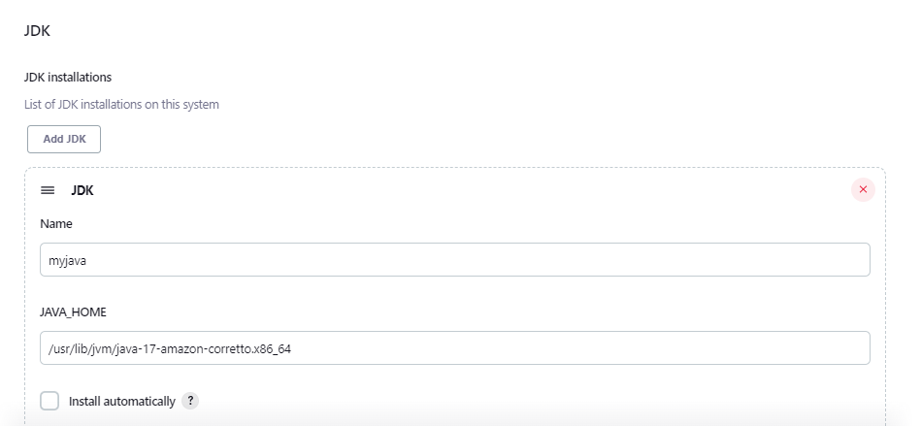

1. gIT installation path to the git executable

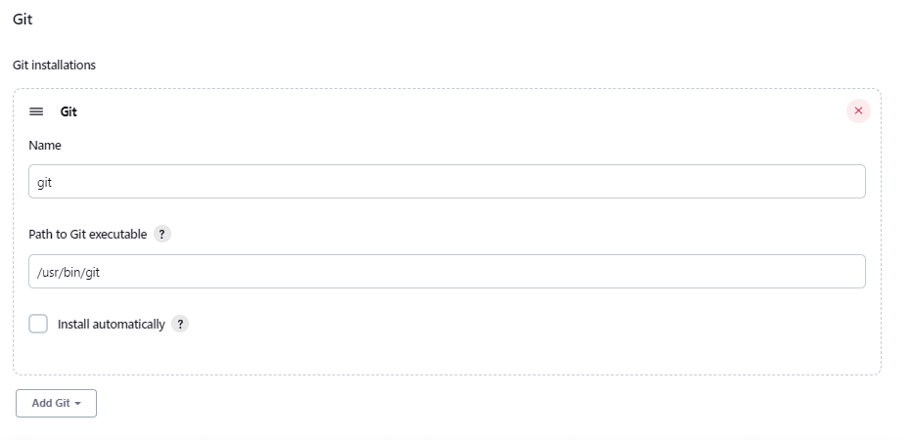

1. In Maven installation give the path where the Maven is installed

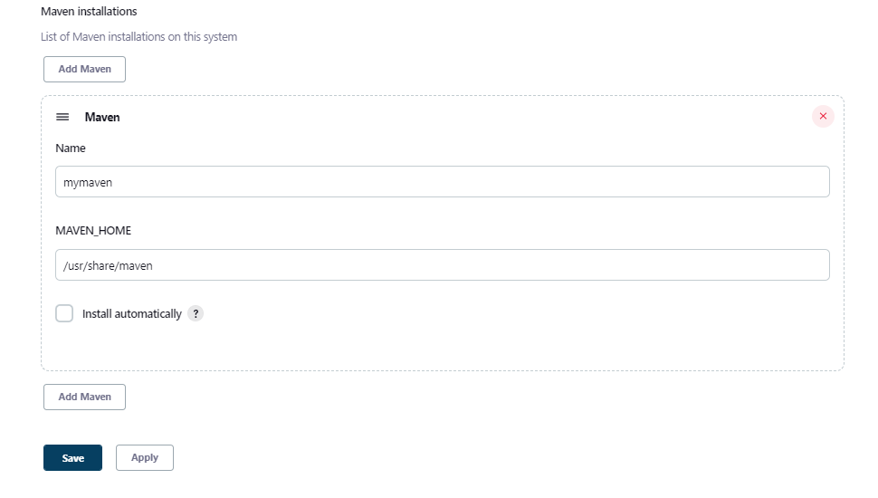

click on save button and our tools configured successfully